**EXP 18 : FOOD ORDERING SYSTEM**

**AIM :** To draw the UML diagrams for food ordering system using umbrello.

**USE CASE DIAGRAM:**

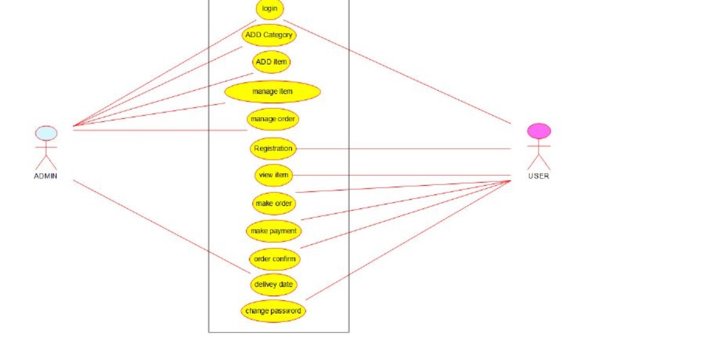

**CLASS DAIGRAM :**

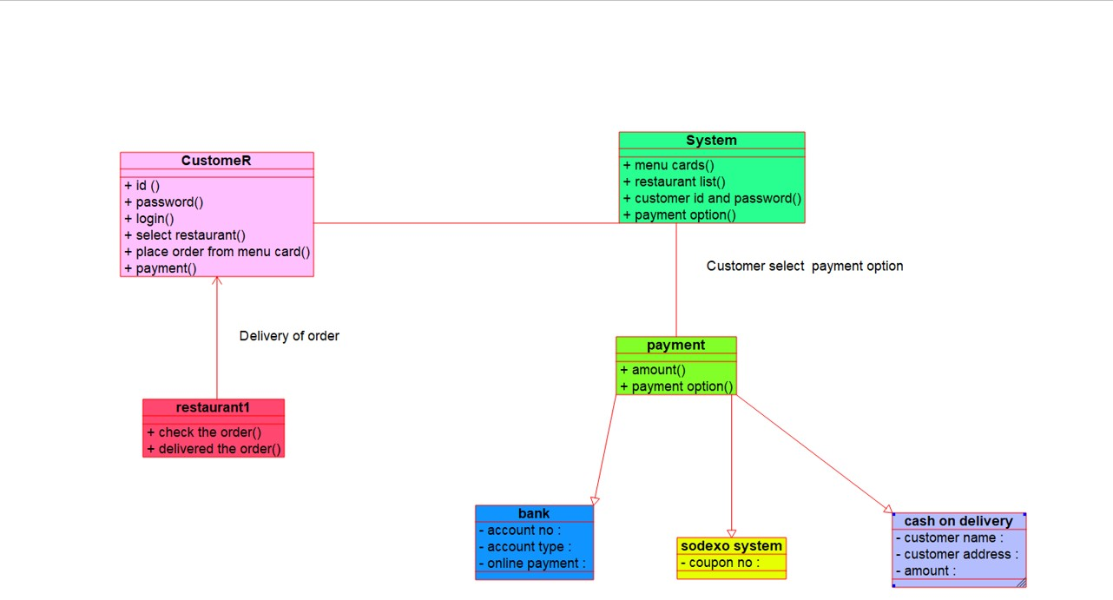

**COLLABRATION DIAGRAM :**

